1. SELECT * FROM `obat` ORDER BY tgl_kadaluwarsa DESC

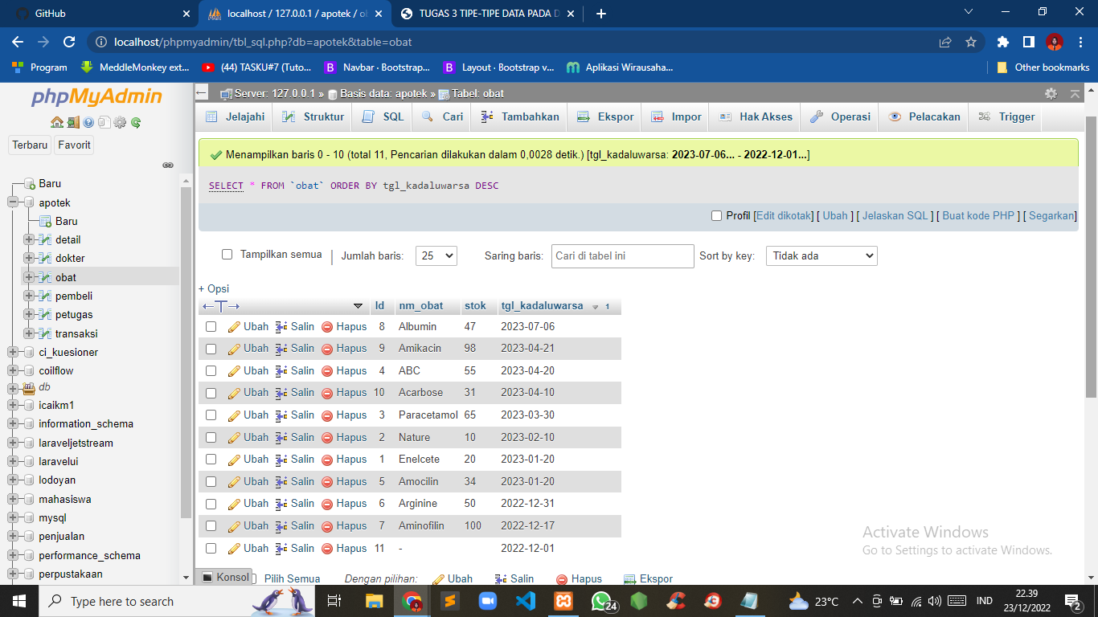

2. SELECT * FROM `detail` ORDER BY tgl_transaksi ASC

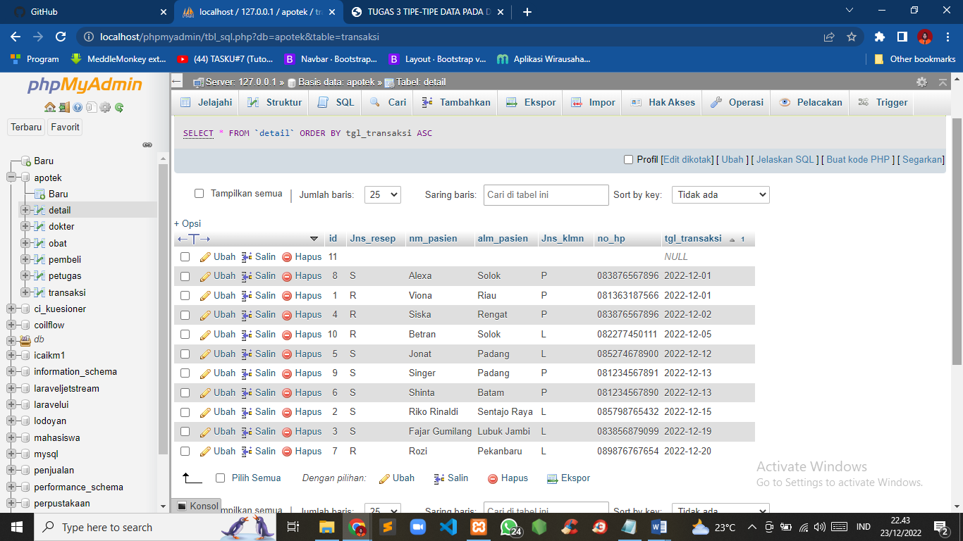

3. SELECT * FROM `dokter` WHERE alamat LIKE '%Padang%'

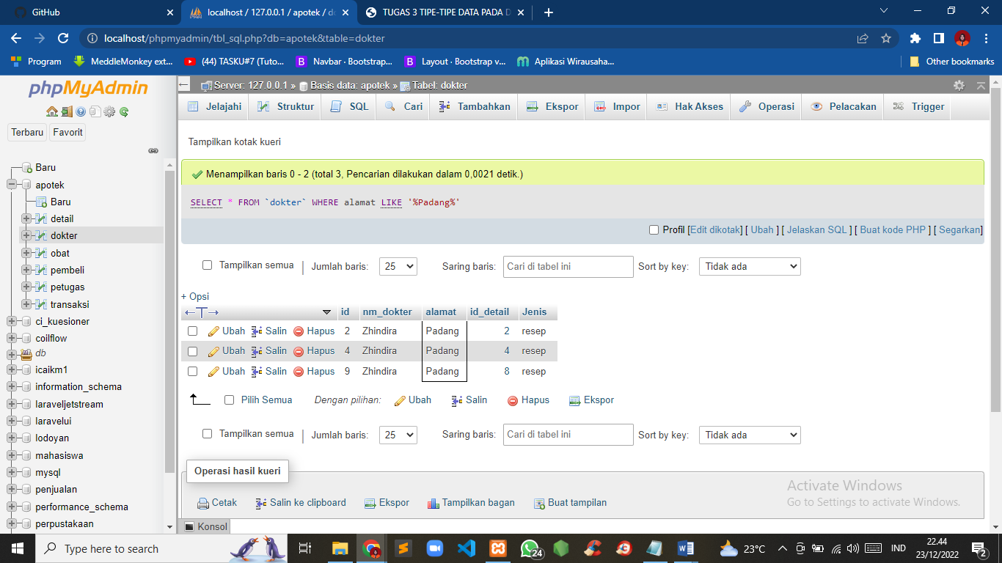

4. SELECT * FROM `petugas` WHERE nm_petugas LIKE '%Refif%'

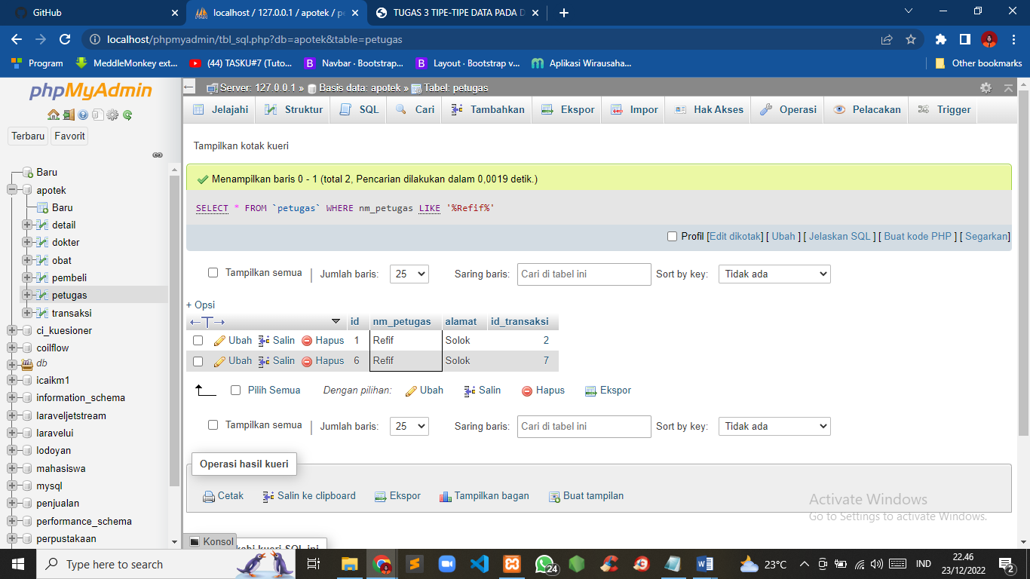

5. SELECT nm_dokter, SUM(id_detail) AS total FROM `dokter` GROUP BY nm_dokter

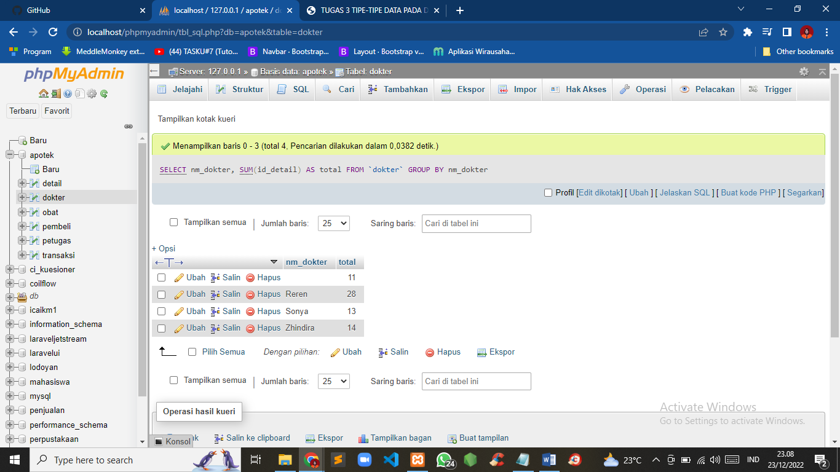

6. SELECT nm_obat, SUM(stok) AS total FROM `obat` GROUP BY nm_obat

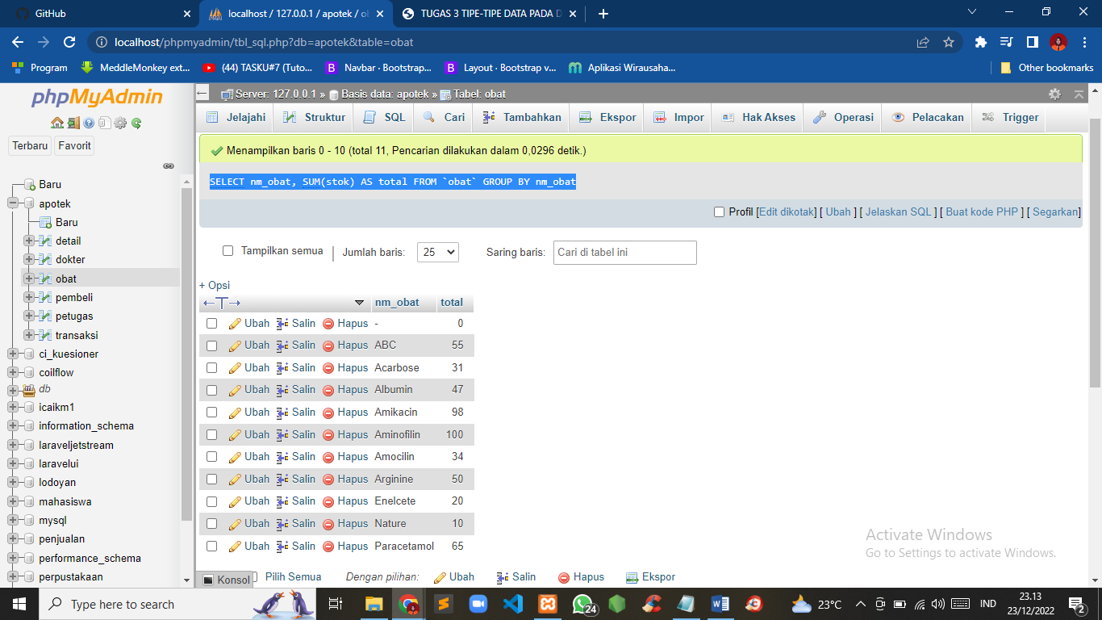

7. SELECT nm_pasien, SUM(Jns_resep) AS total FROM `detail` GROUP BY nm_pasien

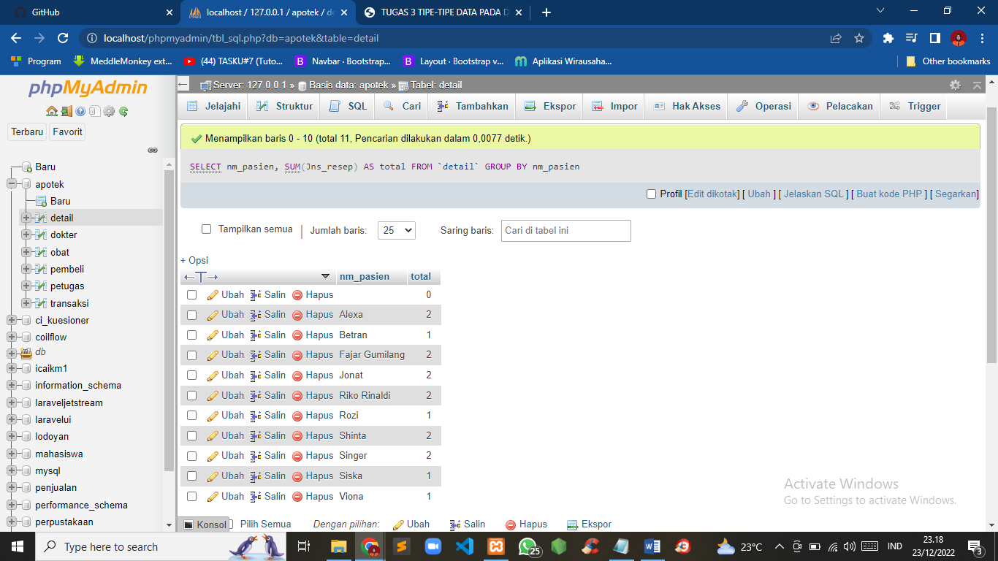

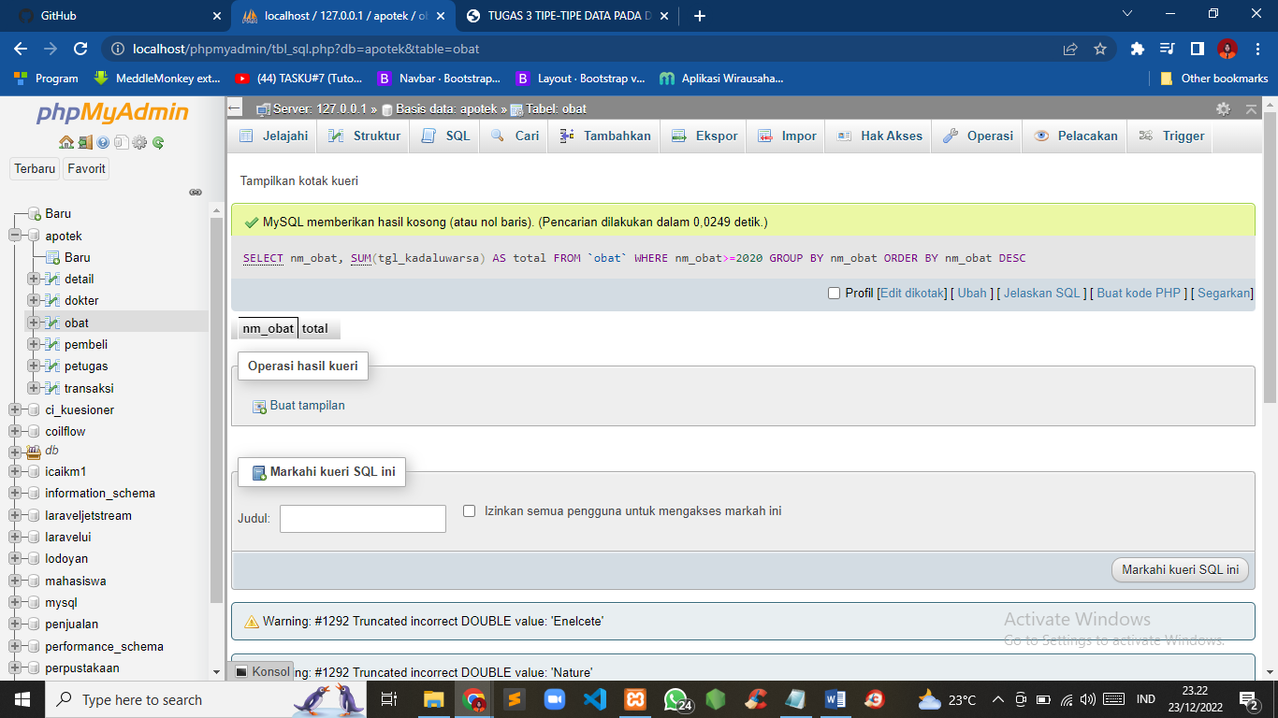8. SELECT nm_obat, SUM(tgl_kadaluwarsa) AS total FROM `obat` WHERE nm_obat>=2020 GROUP BY nm_obat ORDER BY nm_obat DESC

9. SELECT nm_obat, SUM(tgl_kadaluwarsa) AS total FROM `obat` GROUP BY nm_obat ORDER BY nm_obat DESC

10. SELECT nm_obat, SUM(tgl_kadaluwarsa) AS total FROM `obat` GROUP BY nm_obat ORDER BY nm_obat ASC

